Energy Company Obligation: Help to Heat
Local Authority Flexible Eligibility Statement of Intent
Local authority: Exeter City Council
Version: 2.0
Date of publication: 14 August 2017

1) Introduction
Exeter City Council welcomes the introduction of Flexible Eligibility (FE) and intends to utilise it for the purposes of reducing fuel poverty in the City.
It should be noted that the final decision on whether any individual household will benefit from energy saving improvements or heating rests with obligated energy suppliers or their contractors. Inclusion in a Declaration of Eligibility issued by the Council to a supplier will not guarantee installation of measures. The final decision will depend on i) identification of measures eligible under Help to Heat ii) the supplier's assessment of the cost-effectiveness of installing measures in relation to achieving its obligation, and iii) whether the supplier has achieved their targets or require further measures to meet their Energy Company Obligation targets.
In identifying households as eligible under flexible eligibility Exeter City Council is seeking to enable residents to benefit from funding and will seek the consent of households to including them in a Declaration. Exeter City Council expects any obligated energy supplier, or contractor working on their behalf to comply with the Data Protection Act, to fully follow Of gem requirements for the Energy Company Obligation Help to Heat, and to act in accordance with industry best practice in relation to consumer care and quality standards of any works that may take place. These are covered in a separate memorandum of understanding between the Council and the obligated party.

2) How Exeter City Council intends to identify eligible households
Exeter City Council will identify households that may benefit from flexible eligibility in a number of ways:
a. Identifying fuel poverty
Exeter City Council will utilise the Energy Savings Trust Home Analytics Data Base to target fuel poor. The Data base will also be used to target those in poor health once Health Data has been added, a project that is ongoing.
Subject to availability of resources within the Council and the legal use of data the Council will target those most in need having regard to BEIS guidance on targeting, including:
- Those living in private sector and in receipt of the relevant means-tested benefits and/or on a low income
- Those living in energy inefficient Residential Mobile Homes who are over the age of 55
- We will cross-reference data on income with data that we hold or can access on Energy Performance Certificates, prepayment meters, expenditure on fuel, housing type/age/condition, heating type
- Low income households living in energy inefficient housing will be identified in the private rented sector through enforcement activity under the Housing Act 2004
- Household receiving help through the LEAP project
- Private tenants living in properties with E.F and G EPC rating
b. Identifying low income and vulnerability to cold
Exeter City Council will target households containing people with the following characteristics, which reflects the National Institute for Health and Care Excellence (NICE) 2015 guidance on excess winter deaths and illness caused by cold homes.
- Aged over 60 (55 in the case of mobile homes), and particularly those over 75
- Children under 5 and pregnant mothers
- Private tenants on low income living in properties with E. F and G EPC rating
- Respiratory disease (COPD, asthma)
- Cardiovascular disease (e.g. ischaemic heart disease, cerebrovascular disease)
- Moderate to severe mental illness (e.g. schizophrenia, bipolar disorder)
- Dementia
- Neurobiological and related diseases (e.g. fibromyalgia, ME)
- Cancer
- Limited mobility
- Haemoglobinopathies (sickle cell disease, thalassaemia)
- Severe learning disabilities
- Autoimmune and immunodeficiency diseases (e.g. lupus, MS, diabetes, HIV)
Exeter City Council define ‘low income’ in the following table
Household composition | Annual household income | Monthly household income
Single adult | £9790 | £814
Single adult plus 1 child | £12870 | £1078
Single adult plus 2 children | £15840 | £1320
Single adult plus 3 children | £19030 | £1580
Single adult plus 4 or more children | £22110 | £1848
Couple | £16060 | £1340
Couple plus 1 child | £19140 | £1595
Couple plus 2 children | £22220 | £1848
Couple plus 3 Children | £25410 | £2123
Couple plus 4 or more children | £28270 | £2354

c. Solid wall insulation "in-fill" projects
Where potential works have been identified households will be supported to take advantage of "in-fill" projects where the minimum number of vulnerable households is met.

3) Governance
Responsible officer
The officer below will be responsible for signing Declarations on behalf of the local authority.
Name: Keith Williams
Telephone: 01392 265777
Email: keith.williams@exeter.gov.uk

4) Evidence, monitoring and reporting
a. Anonymised data on the characteristics of households reached through FE will be reviewed
b. The data above will include details of households assessed, how many were deemed eligible and ineligible, and how many received heating and insulation improvements
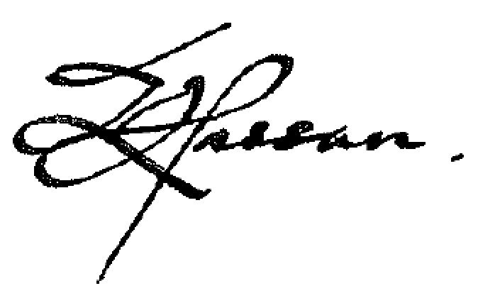
Karime Hassan
Chief Executive and Growth Director
Exeter City Council

